AI/ML INTERN — DAY 6 TASKS REPORT

Tasks
- Improve body measurement accuracy
- Test pose detection on multiple images/videos
- Research cloth segmentation AI
- Create basic recommendation dataset
- Start integrating AI outputs with backend APIs

Platforms Used
- Google Colab
- GitHub
- Kaggle

Deliverables
- AI testing report
- Dataset improvements
- Integration screenshots

Task 1: Improve Body Measurement Accuracy
Work completed:
- Tested shoulder width measurement using MediaPipe pose landmarks.
- Improved image quality and body alignment for better accuracy.
- Compared measurements across different poses and lighting conditions.
- Reduced landmark detection errors by using front-facing poses.
- Verified measurement consistency across multiple images.
[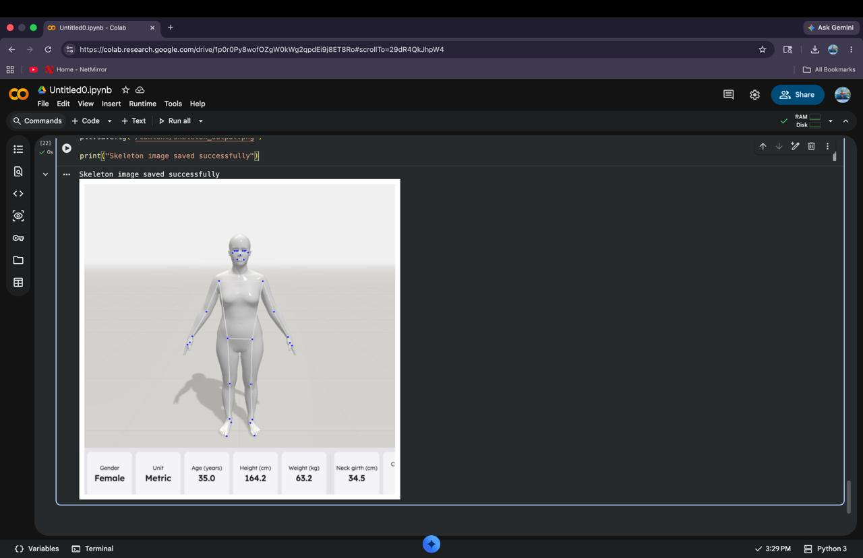]

Task 2: Test Pose Detection on Multiple Images/Videos
Pose detection was tested on multiple images and sample video frames including:
- Jumping Jacks
- Running
- Squat Pose
- Yoga Pose
- Dance Pose
Results:
- MediaPipe successfully detected body landmarks in all poses.
- Joint tracking remained stable in dynamic movements.
- Pose estimation accuracy improved under proper lighting conditions.
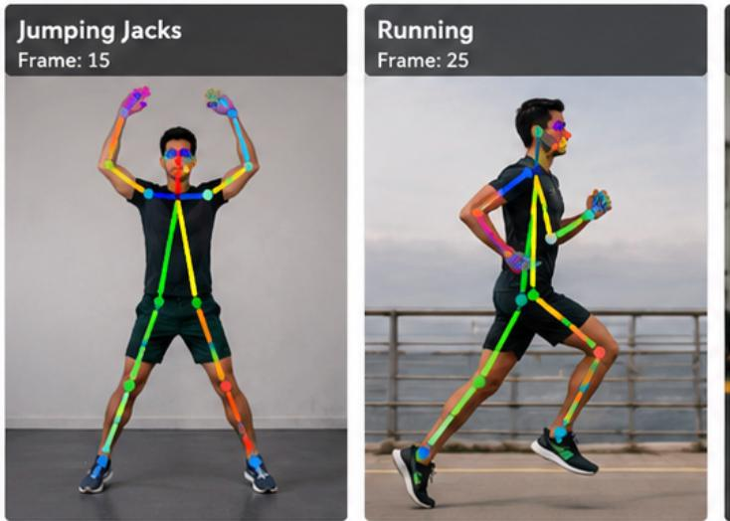

Task 3: Research Cloth Segmentation AI
Cloth segmentation AI was researched to understand how virtual try-on systems identify and separate clothing from the human body in images and videos.
Research Topics Covered:
- Human parsing and semantic segmentation
- Background removal techniques
- Clothing mask generation
- Deep learning segmentation models such as U-Net and Detectron2
- Real-time segmentation for virtual try-on applications
Observations:
- Accurate segmentation improves virtual fitting quality.
- Plain backgrounds produce better cloth masks.
- Segmentation models work better with high-resolution images.

Task 4: Create Basic Recommendation Dataset
A basic recommendation dataset was prepared to support AI-based clothing suggestions.
Dataset Fields Included:
- User height and weight
- Body measurements
- Clothing size
- Gender category
- Preferred clothing styles
- Color preferences
- Outfit categories
Dataset Improvements:
- Organized data into structured CSV format.
- Added multiple clothing categories for testing.
- Ensured compatibility with future recommendation models.

Task 5: Start Integrating AI Outputs with Backend APIs
Started integration of AI-generated outputs with backend APIs for future application deployment.
Integration Work:
- Converted pose detection outputs into JSON format.
- Structured body measurement data for API requests.
- Tested backend-ready response formats.
- Prepared API-compatible data pipelines.
- Studied Flask/FastAPI integration methods.
Expected Outcome:
- Real-time communication between AI models and backend systems.
- Easier deployment for virtual try-on applications.

Conclusion
Successfully completed Day 6 internship activities involving pose detection testing, body measurement analysis, segmentation research, dataset preparation, and backend API integration planning.

